Doctors for Kids – Wellness Division
Massage Health Questionnaire

Name |  | Cell phone |  |  |  | Work phone
Email |  |  |  | Home phone
Street |  | City |  |  |  | State/Zip
Date of Birth | □ Male  □ Female |  | Age |  | Height |  | Weight
Occupation |  | Employer |  |  |  | Physician
Emergency Contact - Name (First & Last) |  | Emergency Contact - Phone |  |  |  | Relation to you

Is this your first professional massage? Y N

What have you liked or disliked with previous massage?

____________________________________________________________________________________

Is there a specific part of the body you would like to focus on?

____________________________________________________________________________________

Is there a specific posture or position you assume most of the day?

____________________________________________________________________________________

CURRENT HEALTH:

Are you presently experiencing any cold or flu like symptoms? Y N

Please inform the therapist, the session might need to be rescheduled

Please list any current medications, vitamins, supplements or herbs you are taking

____________________________________________________________________________________

_____________________________________________________________________________________

Do you have a regular exercise routine? Y N

What type of exercise do you participate in?
____________________________________________________________________________________

Please indicate any areas of pain, tension, tingling or numbness on the diagram below:

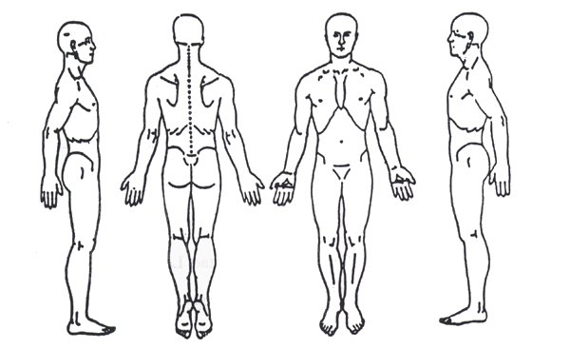

MEDICAL HISTORY: Circulatory  o Heart disease  o High / Low Blood Pressure  o Varicose veins  o Peripheral Artery Disease  o Blood clots  o Hemophilia  o Palpitations  o Stroke  o Other __________________  Digestive  o Crohn’s Disease  o IBS / Colitis  o Constipation / Diarrhea  o Gallstones  o Ulcers  o Other __________________  Other Medical Issues  o Diabetes Type I / Type II  o Cancer _________________  o Thyroid Hyper / Hypo  o HIV/AIDS  o Hepatitis  o Lupus  o Other __________________ | Respiratory  o Asthma  o Pneumonia  o COPD  o Emphysema  o Other __________________  Neurological Conditions  o Seizures (type) ___________  o Multiple Sclerosis  o Carpal Tunnel  o Bell’s Palsy  o Tingling/Numbness  o Other __________________  Emotional Difficulties  o Depression  o Anxiety  o Other __________________  Allergies (please specify)  o Nuts  o Environmental  o Medications  o Other __________________ | Skin Conditions  o Acne  o Eczema / Psoriasis  o Fungal Infections  o Athlete’s Foot  o Open cuts / sores  o Bruises  o Sunburn  o Other __________________  Musculoskeletal  o Osteoporosis  o Arthritis  o Rheumatoid Arthritis  o Gout / Bursitis  o Fractures / Strains / Sprains  o TMJ  o Tendonitis  o Fibromyalgia  o Whiplash  o Cysts / Lypomas  o Headaches  o Other __________________

Skin Test for "Special Oil" Please insert Name of Oil: ___________________________________

Was Performed 24 hours or more ago and there has been no reaction (please initial) _________

To the best of my knowledge the information completed on all three pages of this document is correct

Signed:_______________________________________________Date: ______________________

Printed Name: ____________________________________________________________

Informed Consent for Massage

I understand that the massage/bodywork I receive is provided for the basic purpose of relaxation and relief of muscular tension. If I experience any pain or discomfort during this session, I will immediately inform the practitioner so that the pressure and/or strokes may be adjusted to my level of comfort. I understand that massage/bodywork practitioners are not qualified to perform spinal or skeletal adjustments, diagnose, prescribe, or treat any physical or mental illness, and that nothing said in the course of the session given should be construed as such. Because massage/ bodywork should not be performed under certain medical conditions, I affirm that I have stated all my known medical conditions and answered all questions honestly. I agree to keep the practitioner updated as to any changes in my medical profile and understand that there shall be no liability on the practitioner’s part should I fail to do so. Children under the age of 18 must be accompanied by parent or legal guardian at all times during massage.

Signature required prior to each massage and any changes documented and initialed prior to each massage.

Parent/Guardian Signature: __________________________________Date________________

Therapist Signature: ________________________________________ Date _______________
Parent/Guardian Signature: __________________________________Date________________

Therapist Signature: ________________________________________ Date _______________
Parent/Guardian Signature: __________________________________Date________________

Therapist Signature: ________________________________________ Date _______________
Parent/Guardian Signature: __________________________________Date________________

Therapist Signature: ________________________________________ Date _______________
Parent/Guardian Signature: __________________________________Date________________

Therapist Signature: ________________________________________ Date _______________
Parent/Guardian Signature: __________________________________Date________________

Therapist Signature: ________________________________________ Date _______________
Parent/Guardian Signature: __________________________________Date________________

Therapist Signature: ________________________________________ Date _______________
Parent/Guardian Signature: __________________________________Date________________

Therapist Signature: ________________________________________ Date _______________
Parent/Guardian Signature: __________________________________Date________________

Therapist Signature: ________________________________________ Date _______________
Parent/Guardian Signature: __________________________________Date________________

Therapist Signature: ________________________________________ Date _______________
Parent/Guardian Signature: __________________________________Date________________

Therapist Signature: ________________________________________ Date _______________
Parent/Guardian Signature: __________________________________Date________________

Therapist Signature: ________________________________________ Date _______________
Parent/Guardian Signature: __________________________________Date________________

Therapist Signature: ________________________________________ Date _______________
Parent/Guardian Signature: __________________________________Date________________

Therapist Signature: ________________________________________ Date _______________
Parent/Guardian Signature: __________________________________Date________________

Therapist Signature: ________________________________________ Date _______________
Parent/Guardian Signature: __________________________________Date________________

Therapist Signature: ________________________________________ Date _______________

