
Outpatient Breastfeeding
Consultation Services

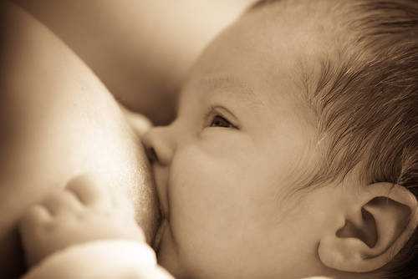

Available to all mothers and babies in need of help with latching, sore nipples, infection, and troubleshooting of any breastfeeding concern.

Baby is weighed before and after feeding to assess milk transfer.
Will work to optimize breastfeeding experience.

This service is not billed to insurance.
Cost is $120 for a 1.5 hour consultation payable at time of booking. Each additional 0.5 hour $40 billed in half hour blocks and payable before leaving consultation.

For appointments:
Email: patient.concierge@drmavani.org

(248) 650-5009 - option #6

Please visit our website www.drmavani.org any time for Doctors For Kids practice information

Dennette Fend, RNc, MSN, WHNP, IBCLC
Nurse Practitioner & Lactation Consultant

Doctors for Kids, 940 W Avon Road, Suite 11, Rochester Hills, MI 48307.
Ph. (248)650-5009

